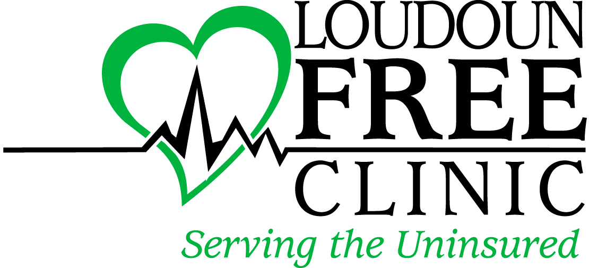

Loudoun Free Clinic
Job Description

Job Title: Clinical Director
Department: Loudoun Free Clinic
Reports to: Executive Director
Salary Level: Full-Time
FLSA Status: Salaried Exempt
Developed: May 2011
Revised: February 2020

Summary: The Clinical Director is a member of the leadership/management team of the Clinic. He/she promotes health and wellness in the community through the provision of professional nursing care at the Loudoun Free Clinic and outreach to the surrounding community and overseeing the day to day operations of The Clinic.

Essential duties and responsibilities include the following. Other duties may be assigned.

Patient Care
- Assessing patient needs based upon physical exam and health history as a nurse.
- Performing diagnostic tests as ordered by the provider staff.
- Formulating nursing diagnoses and plans of care.
- Providing health and wellness education for all clients delivered in a culturally competent manner.
- Ensuring efficient patient care and patient flow processes
- Providing case management assistance in collaboration with providers and staff
- Developing and implementing the clinic’s annual quality improvement plan in collaboration with the Medical Director.
- In partnership with Medical Director, coordinating the on-boarding process of providers (employed and volunteer) including credentialing and re-credentialing.

Leadership/Management
- Responsible for volunteer and paid provider and clinical staff scheduling.
- Responsible for performance evaluations of clinical support staff
- Develops/updates clinical policies and procedures and ensures compliance with such policies/procedures
- Participate in identification of grant opportunities and development of grant applications
- Assist in providing quarterly and annual reports as required for the Virginia Association of Free Clinics compliance
- Assists in monitoring and staying within yearly budget, under guidance of the Executive Director.
- Responsible for ensuring that equipment and supplies are in stock and updated.
- Develop annual nursing goals and objectives that reflect Clinic’s Strategic Plan and Priorities. Provide quarterly updates on progress towards achieving those goals
- Participate as a Member of clinical/administrative/community committees as designated by the Medical Director, Executive Director and/or community leaders.

Employee Health/Infection Control/Quality Improvement
- Implements and maintains nursing staff competence.
- Oversees/responsible for Infection Control policies and procedures to reduce risk to both patients and staff acquiring preventable infection.
- Oversees/responsible for Hazard Materials policies and procedures
- Oversees/responsible for proper medication/vaccination handling, storage, tracking.
- Oversees/responsible for maintaining compliance with Board of Pharmacy, Board of Nursing, Board of Medicine Regulations as appropriate to clinic setting.
- Implements procedures and policies to reduce nosocomial infections.
- Promotes a safe environment for patients and employees through education, prevention, and control of clinic and community infections.
- Maintains that medical equipment is working properly and serviced as required.

QUALIFICATIONS:

BSN required. Minimum of four years clinical experience in acute care or ambulatory setting required including not less than one year in a supervisory position. Fluency in English required and Spanish preferred. Basic Life Support (BLS) certification required. Free Clinic/Community Health Center experience highly preferred.

COMPETENCIES AND EXPECTATIONS:
- Demonstrated ability to be a team player.
- Strong track record of positive peer, physician and administrative relationships.
- Possess cultural sensitivity and competence.
- Requires excellent oral and written communication skills.
- Well organized and able to handle conflicts and crisis in a professional manner.
- Knowledge of comprehensive health programs, public health principles, preventive care recommendations, clinical practice guidelines and quality improvement.
- Ability to maintain complete confidentiality.
- Ability to read and interpret documents such as safety rules, operating and maintenance instructions, procedure manuals in English. Ability to write routine reports and correspondence. Ability to speak effectively in public or with employees.
- Ability to add, subtract, multiply, and divide in all units of measure, using whole numbers, common actions, and decimals. Ability to compute rate, ratio, and percent and to draw and interpret bar graphs.
- Ability to apply common sense understanding to carry out instructions furnished in written, oral, or diagram form. Ability to deal with problems involving several concrete variables in standardized situations.
- To perform this job successfully, an individual should have knowledge of Microsoft Office applications.

WORKING CONDITIONS AND PHYSICAL EFFORT:
- Work will be performed primarily on-site at the Clinic. Off-site activities may include outreach efforts and community health activities.
- Reasonable/limited physical effort is required.
- There is minimal exposure to physical risks, such as operating dangerous equipment and hazardous chemicals.
- Average risk of exposure to infectious diseases through patient contact and/or needle stick or other injury. Strict adherence to OSHA standards will minimize risk.
- Reasonable accommodations are provided according to the American Disabilities Act.

